Set A

1. Write a script to create XML file named “Course.xml”

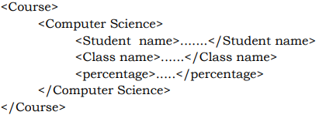

Store the details of 5 students who are in TYBSc.

1. Link “Course.xml” file to the CSS style sheet and get well formatted output as given below

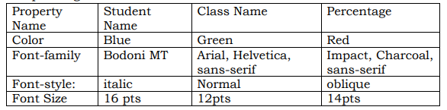

3)Demonstrate the use of json_encode()

4) Demonstrate the use of json_decode()

Set B:

1. Write PHP script to generate an XML code in the following format

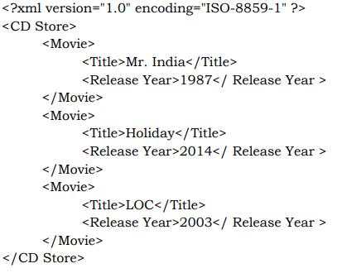

1. Create a XML file which gives details of movies available in “Mayanagari CD Store” from following categories a) Classical b) Action c) Horror

Elements in each category are in the following format 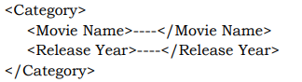

Save the file with name “movies.xml”.

Set C

1) Create an application that reads “book.xml” file into simple XML object. Display attributes and elements (Hint:simple_xml_load_file() function)

2) Write a script to create “cricket.xml” file with multiple elements as given below

